INTERNSHIP ASSESSMENT FORM
(To be completed by the Intern Supervisor)

This evaluation is designed primarily to provide feedback on job performance and related issues to assist the student. This form is to be completed and submitted at the end of the semester.
CSIN: INTERNSHIP
STUDENT INFORMATION
STUDENT’S NAME: Shreyas S Kadapatti
USN: 1MS22CS140
STARTING DATE (DD/MM/YYYY):23/02/2026 | COMPLETION DATE (DD/MM/YYYY): 29/05/2026
SUPERVISOR INFORMATION
NAME: Sanket Joshi |  | JOB TITLE: Senior Tech Engineer
ORGANIZATION’S NAME: Opus Technologies |  | PHONE NUMBER: 7573895859
EMAIL ADDRESS: Sanket.joshi@opustechglobal.com |  | SIGNATURE WITH SEAL:  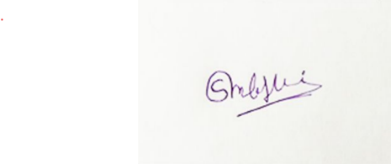

RATING IDENTIFICATION

5‐Outstanding‐ Performance is exceptional in all areas and is clearly superior to others.  4‐ Very Good‐Results clearly exceed most position requirements. Performance is of high quality and is achieved on a consistent basis |  | 3‐ Good ‐ Competent levels of performance that consistently meet job standards.  2‐ Improvement Needed ‐ Performance is deficient in certain areas and improvement is needed.  1‐ Unsatisfactory ‐ Results are generally unacceptable and require immediate improvement
This rating sheet is used to evaluate a student's performance and to help students improve future performance.
Communication: | Demonstrates the ability to speak, listen ,read, and write in performing job tasks: |  | 5
Problem Solving: | Identifies problems, understands their context, and develops workable solutions: |  | 5
Decision‐Making: | Demonstrates the ability to learn and make decisions necessary to complete job tasks successfully: |  | 5
Organization/Time  Management: | Completes assigned tasks from start to finish by gathering, organizing, and evaluating  Information as necessary, and using good time management skills: |  | 5
Professionalism: | Meets workplace standards on confidentiality, flexibility, appearance, and making a good impression: |  | 5
Interactions with  Others: | Works professionally and respectfully with a diversity of co‐workers, supervisors, and resolves conflicts in a constructive manner: |  | 5
Quality of Work: | Performance of tasks is of high quality‐‐generally, error-free or with few errors: |  | 5
All Aspects of  Organization/Industry: | Understands the dynamics of the organization, including health and safety issues, and the role of the business within the community: |  | 5
Attendance/ Punctuality: | Maintains consistently excellent record of attendance and punctuality, rarely being absent or late and always with the notification: |  | 5
Attitude: | Shows enthusiasm and a positive attitude for the job and successfully completes all assigned tasks: |  | 5
Total Marks | 50 |  | 50

